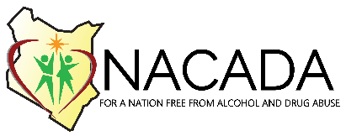
TRAINING BOOKING FORM
INDIVIDUAL BOOKING DETAILS
Participant name
Employer
Mobile number
Email address
County
Type of training
Training dates booked
Date of payment

ORGANIZATION/GROUP BOOKING DETAILS
Name of contact person
Mobile number
Email address of contact person
Organization
County
Number of participants
Name, Telephone and email addresses of participants | Name | Tel. No | Email address
Type of training
Training dates booked
Date of payment
PAYMENT: Deposit the course fee in the account below:
Account Name: National Authority for the Campaign Against Alcohol and Drug Abuse (NACADA)
Account No.: 0180296330592
Bank: Equity Bank
Bank Code: 068
Swift Code: EQBLKENA
Branch: Community
Pin: P051211631H
VAT: N/A (Appointed Agency)
Registered Office: NSSF Building

Please return complete form by email via training@nacada.go.ke
NATIONAL AUTHORITY FOR THE CAMPAIGN AGAINST ALCOHOL AND DRUG ABUSE
P.O.BOX 10774, 00100 GPO NAIROBI. NSSF BUILDING, BLOCK A, EASTERN WING, 18TH FLOOR
TELEPHONE (020)2721997/3; email ceo@nacada.go.ke

